TaLender – Project Booklet
Authors: Wei Han• Luca Attanasio • Simone Cerino
Process: 4 Sprints × 2 weeks (≈ 2 months)

1. Project Overview
Project Name | TaLender
Objective | Connect people who offer skills with people who seek them; enable discovery, preference/match, and real‑time chat.
Scope | Auth (email+Google), profile & skills, discovery with filters/sort, swipe-like preference & match, chat & messages, basic moderation, location opt‑in endpoints.
Users & Roles | End User; Moderator (remove content, delete abusive accounts).
Tech Stack | Frontend: React (Vite, TypeScript) • Backend: Node.js (Express, TypeScript) • DB: MongoDB (Mongoose) • Auth: JWT + Google OAuth • Realtime: Socket.IO
Timeframe | 2 months total — 4 Sprints × 2 weeks
Team | Wei • Luca • Simone
Deliverables | Running system; GitHub repo; input.txt, DataMetrics.json, Student_doc.md; estimation & process booklet.

2. Scrum Plan

Sprint 1 — Auth, Profile & Skills baseline
Stories
US-1 Create account
US-2 Login
US-3 Modify account data
US-4 Access main page
US-5 Modify offered skills
US-17 Logout
US-6 Delete account

Sprint 2 — Discovery, Filters/Sorting, Swipe & Preference (2 weeks)
Stories
US-7 Select interested skills
US-10 Show relevant skills
US-11 Filter skills
US-12 Sort skills
US-13 Swipe one-by-one
US-19 Edit interests and filters

Sprint 3 — Chat, Messaging & Match Notifications (2 weeks)
Stories
US-14 Instant chat with matches
US-20 Message other users
US-15 Receive match notification

Sprint 4 — Moderation, Location Opt‑in, Hardening & Docs (2 weeks)
Stories
US-8 Report inappropriate content
US-9 Moderator removes inappropriate content
US-16 Moderator deletes accounts
US-18 Share location (opt-in)

3. Application Mockups
Mockups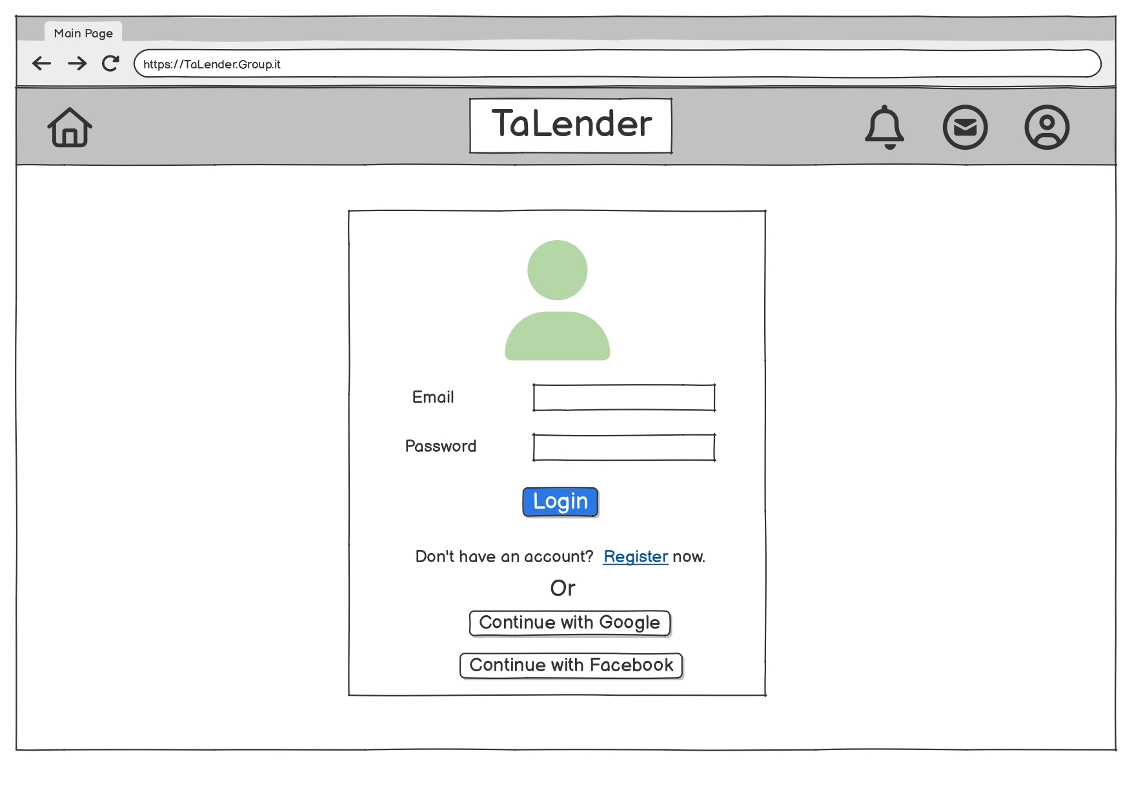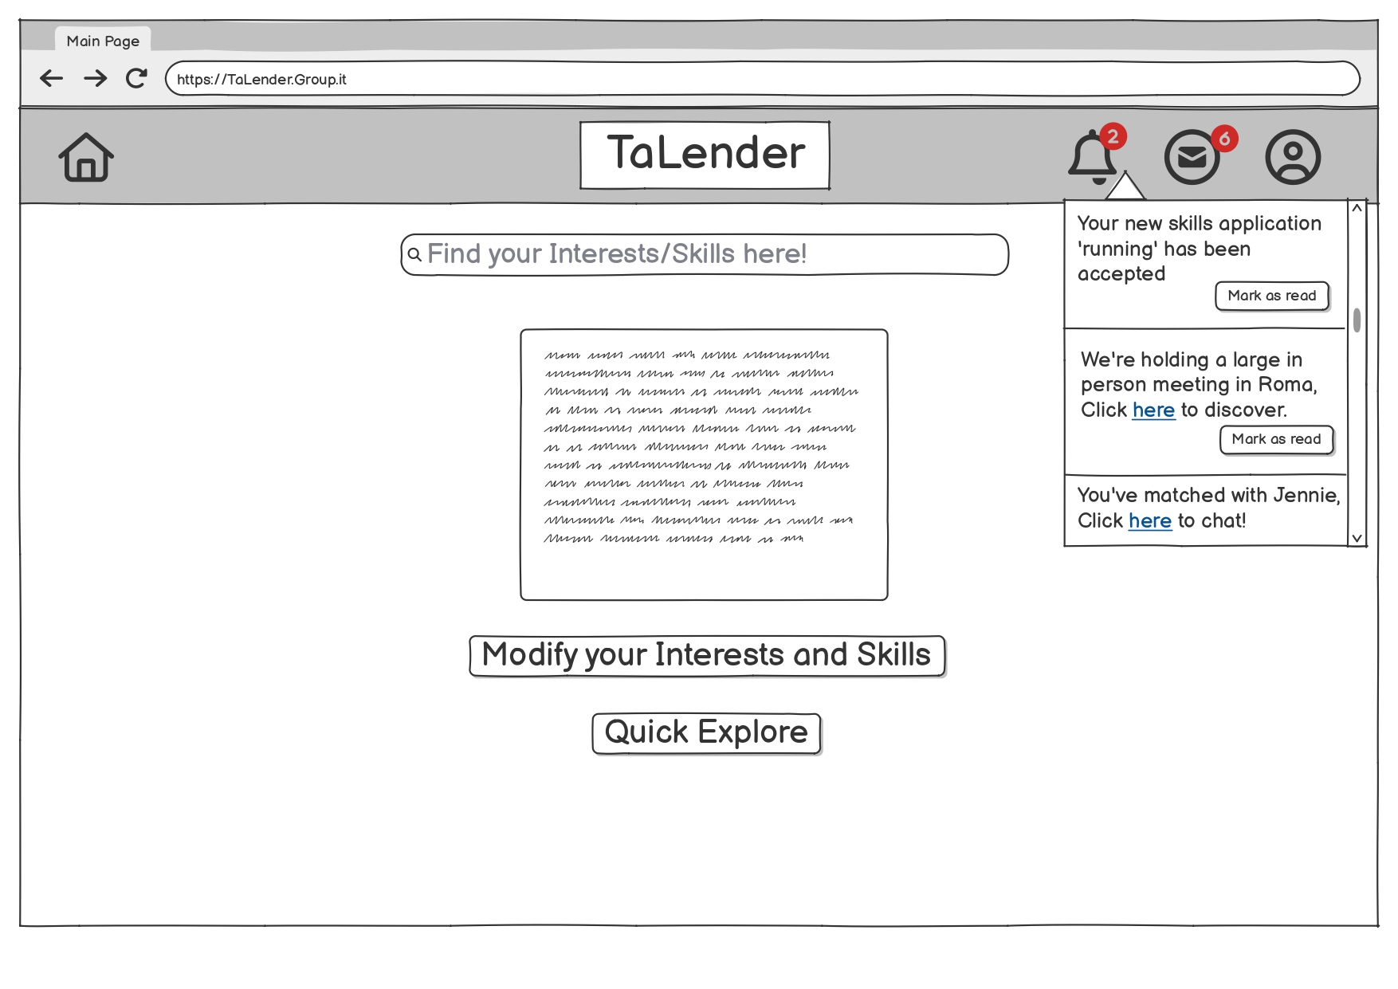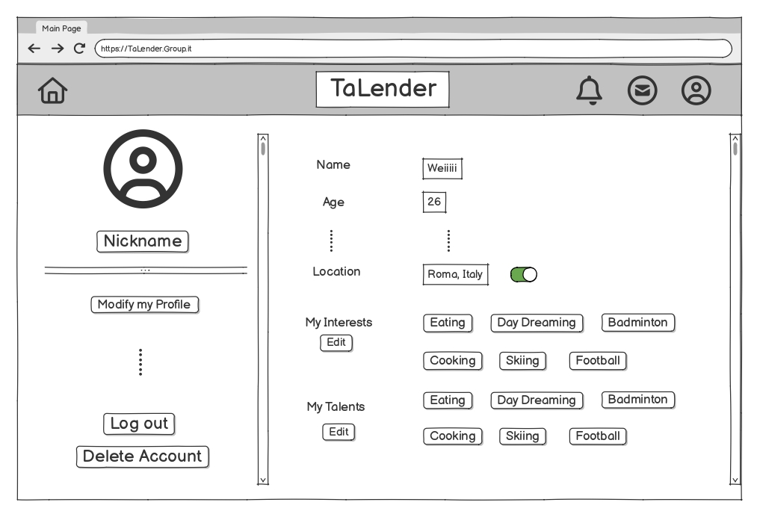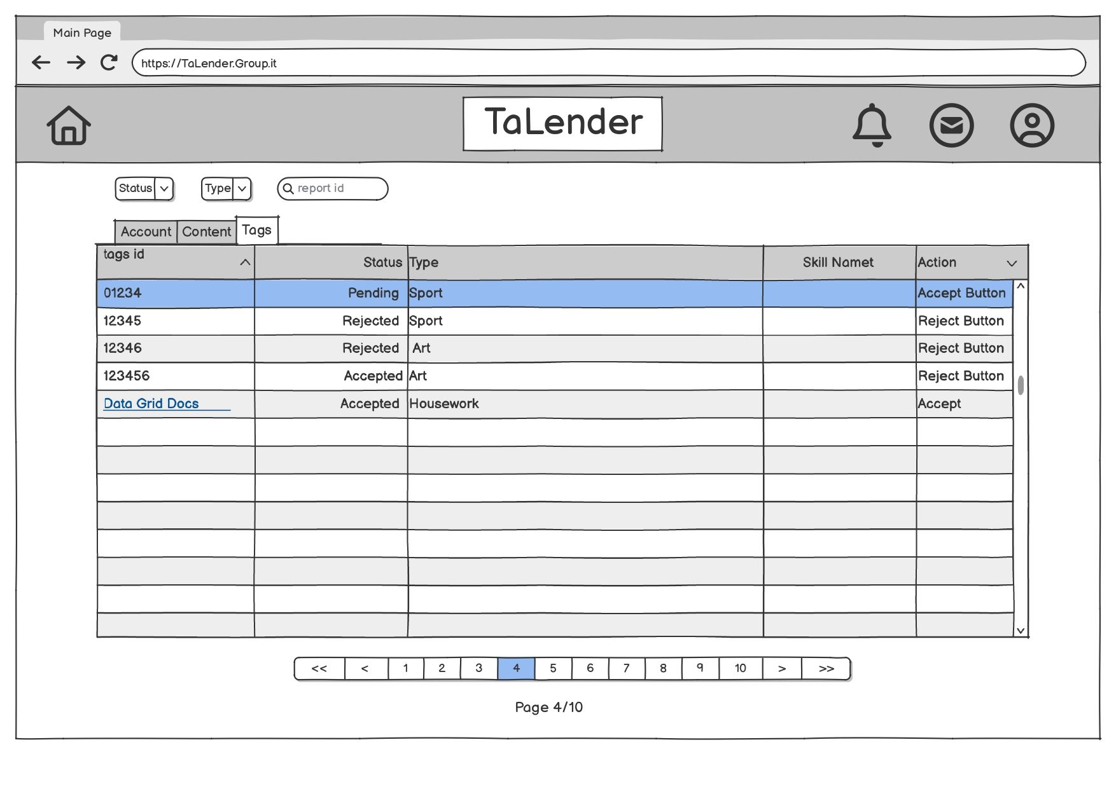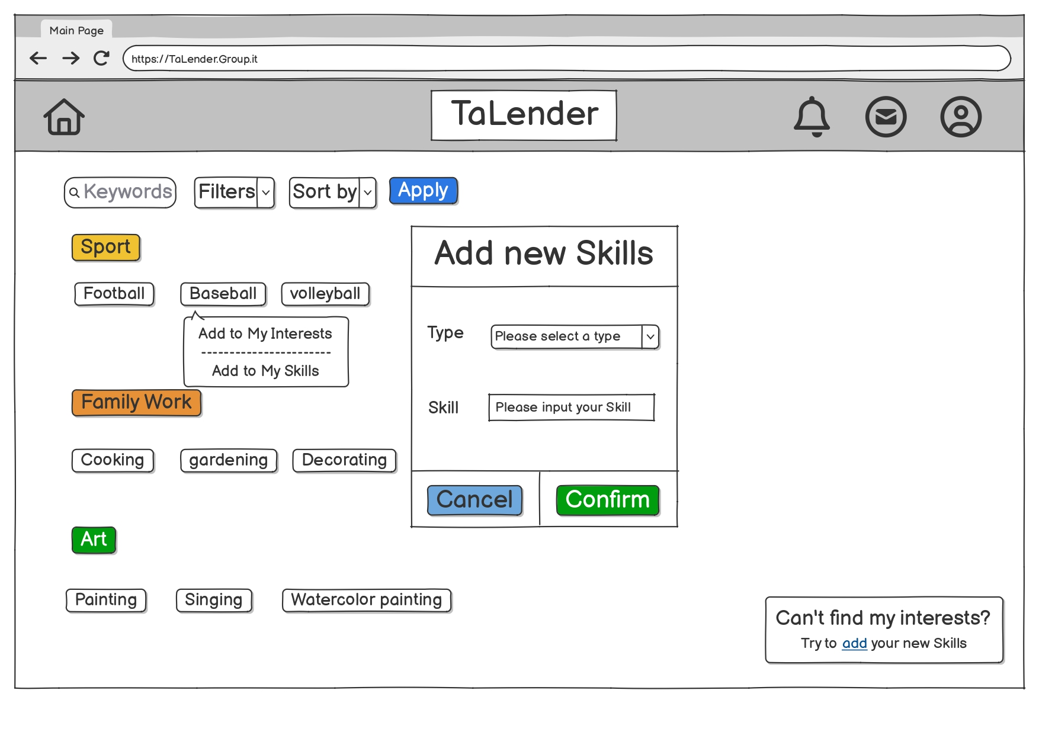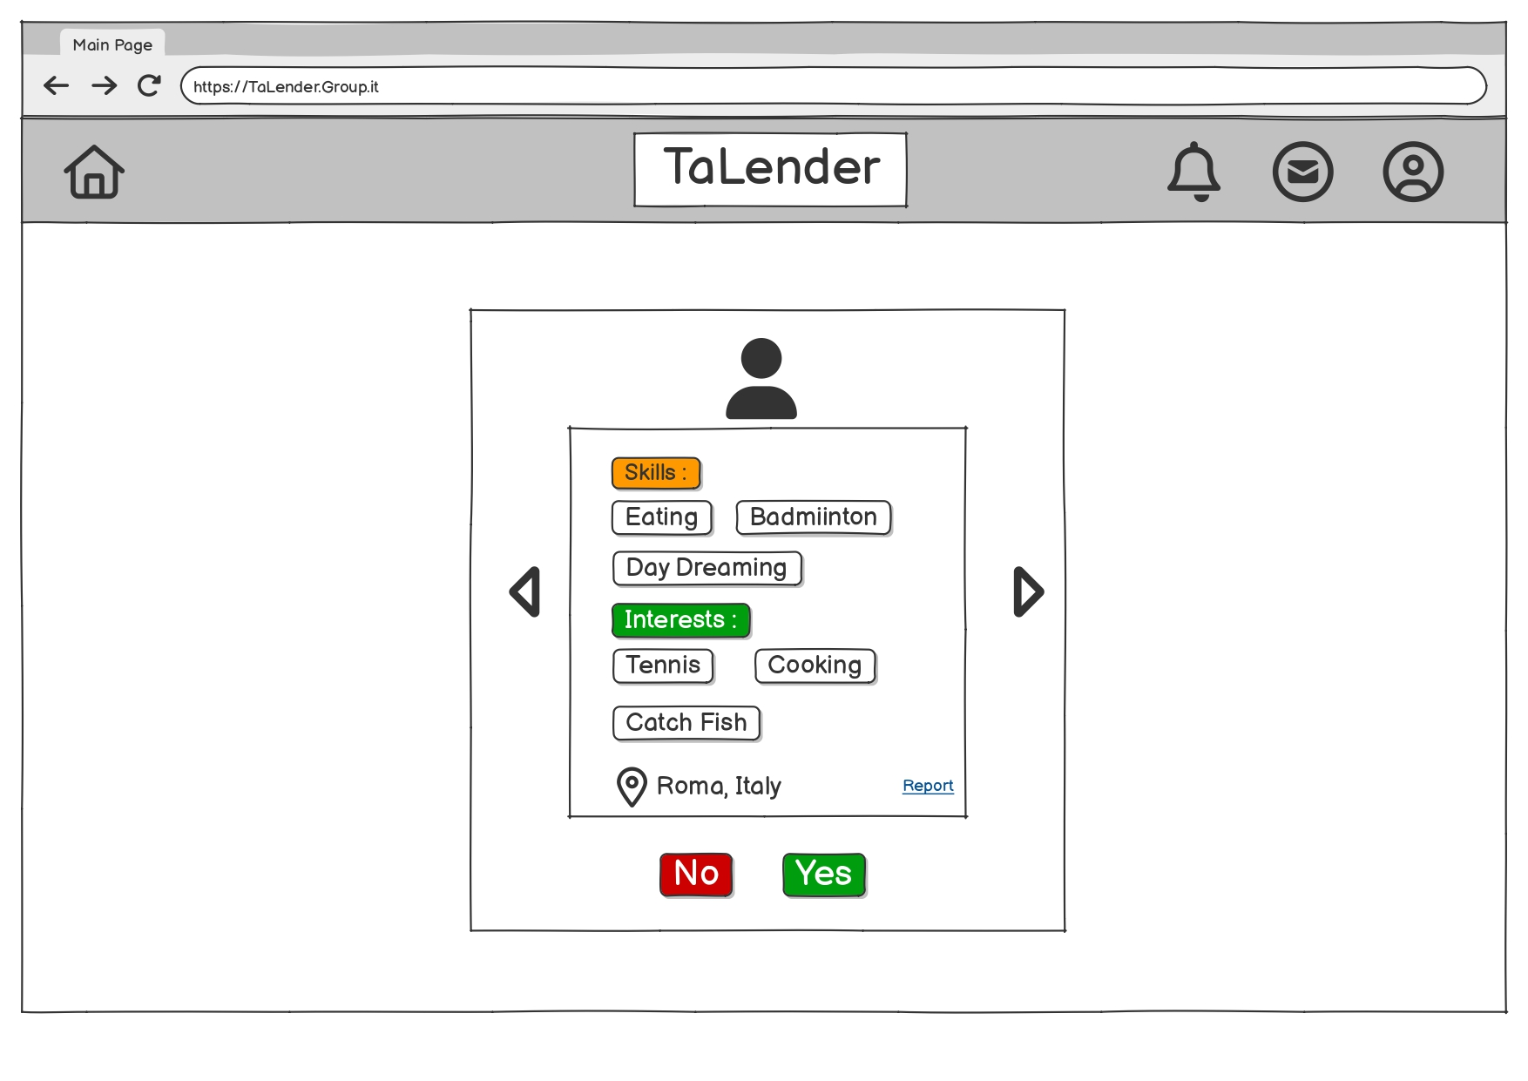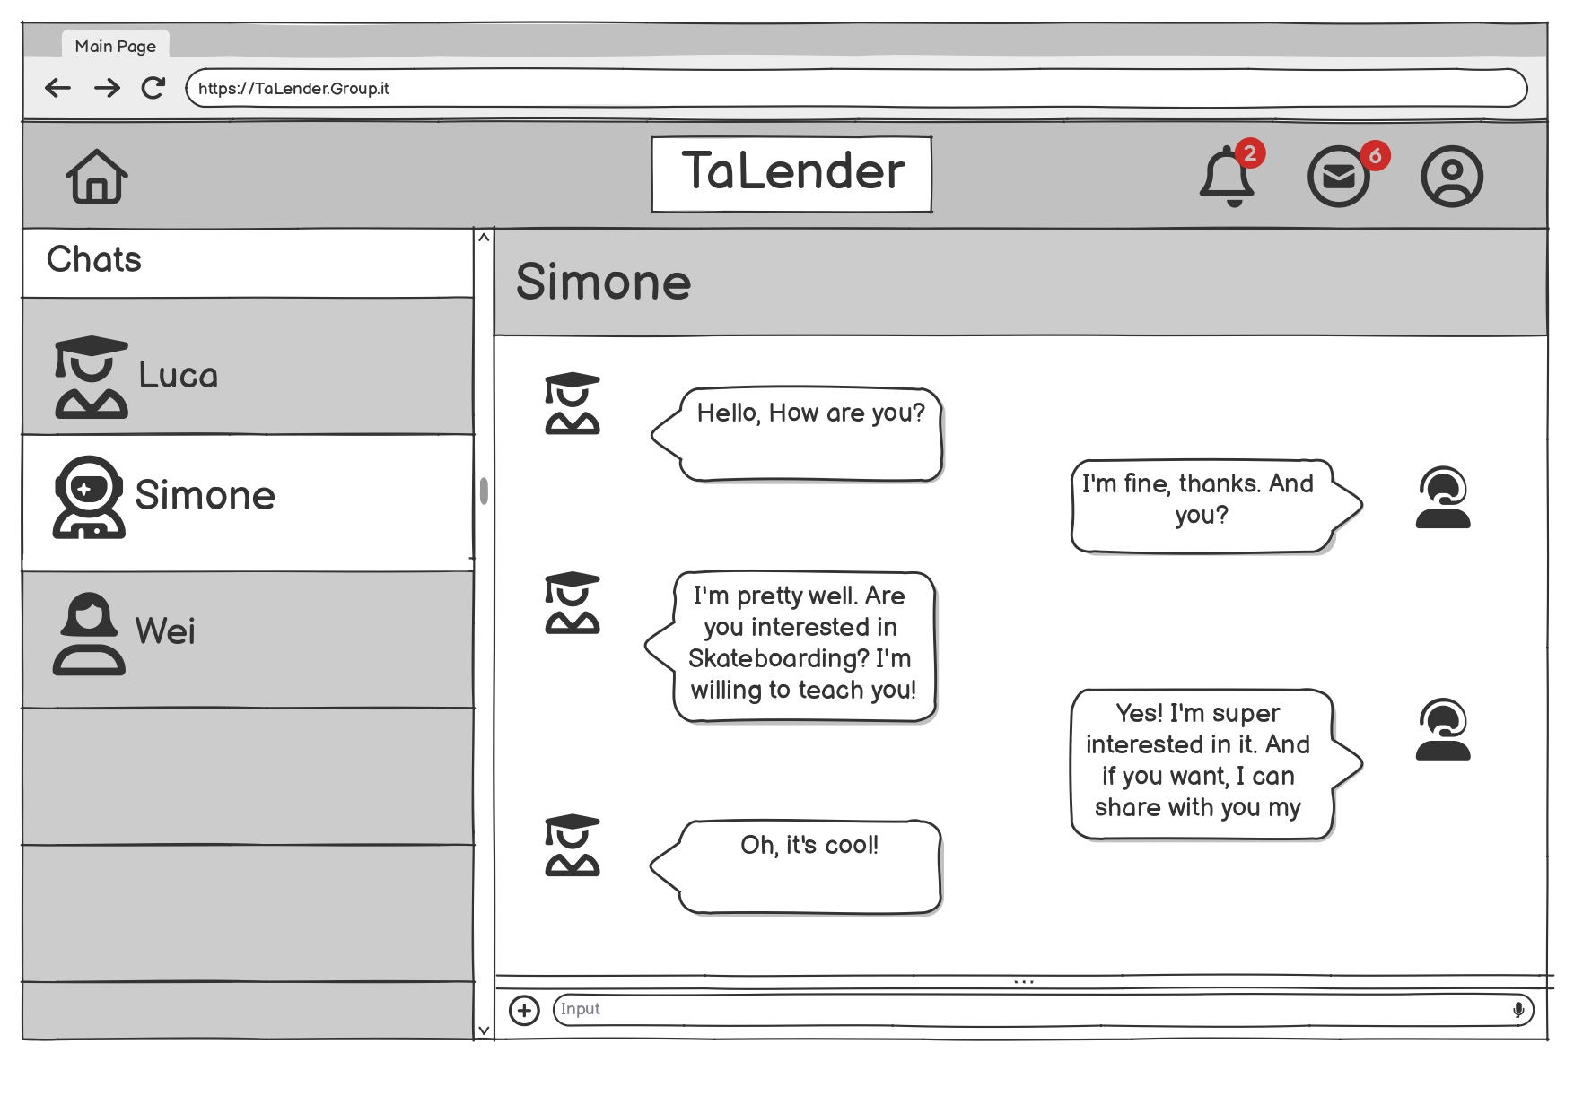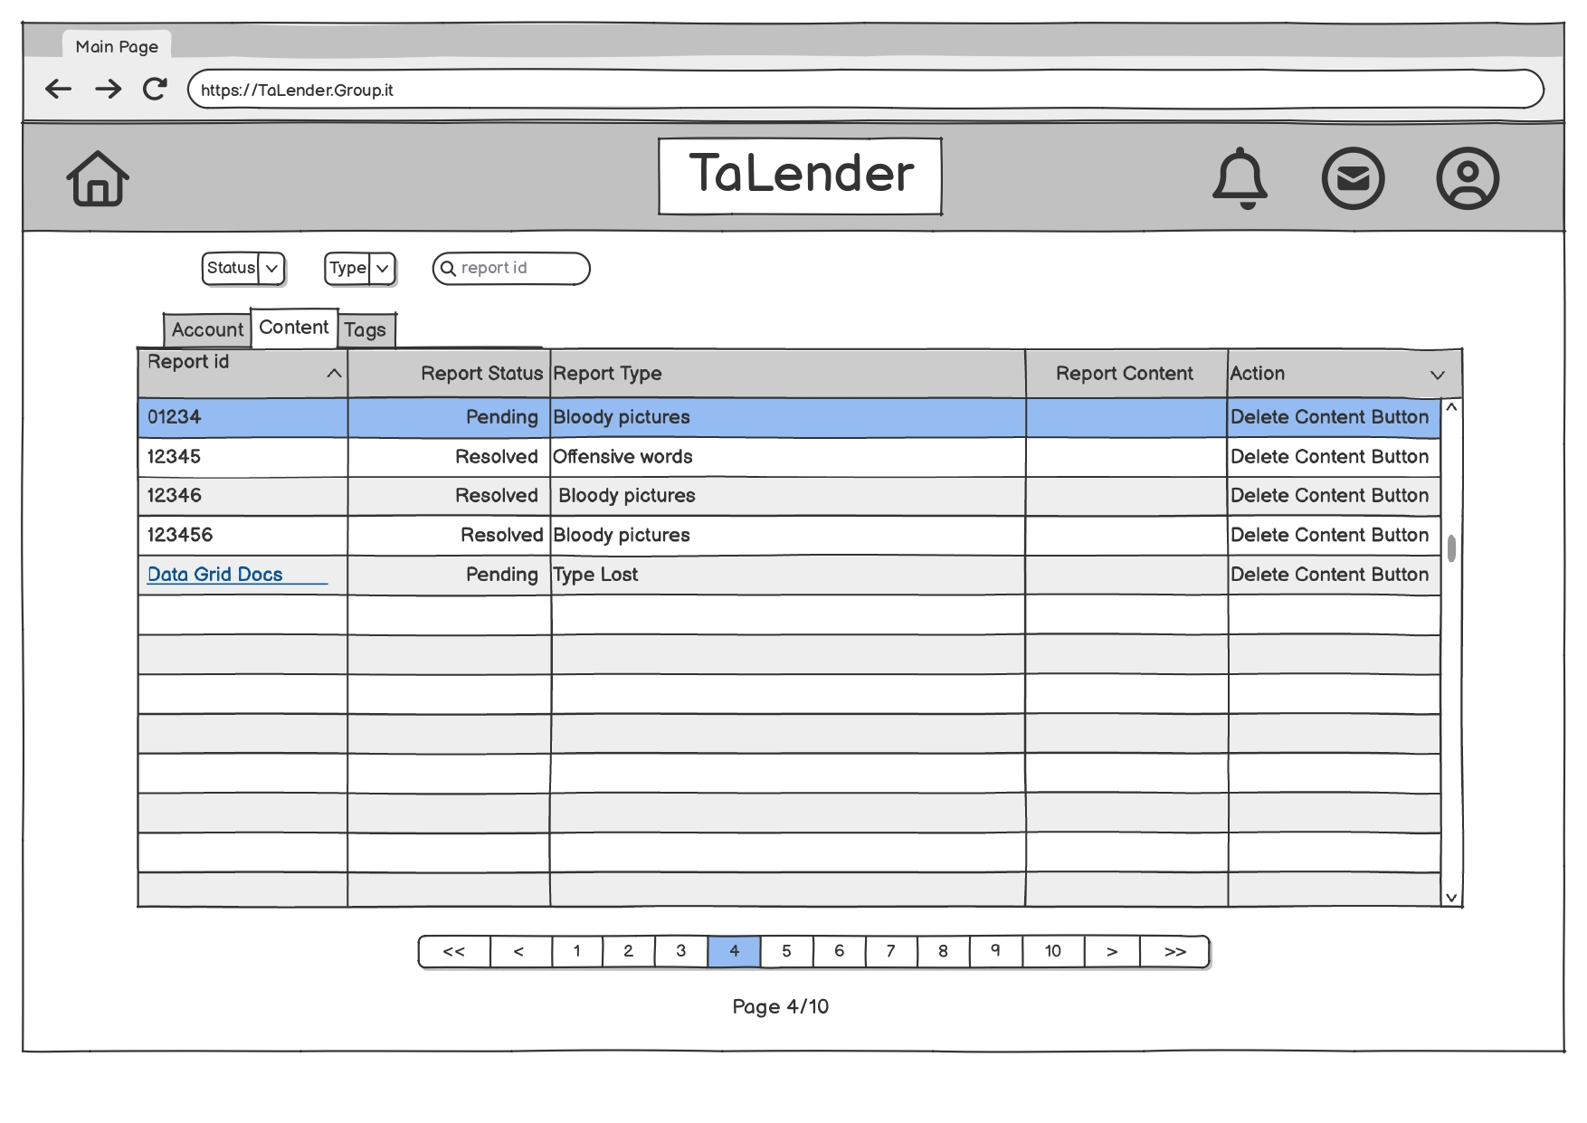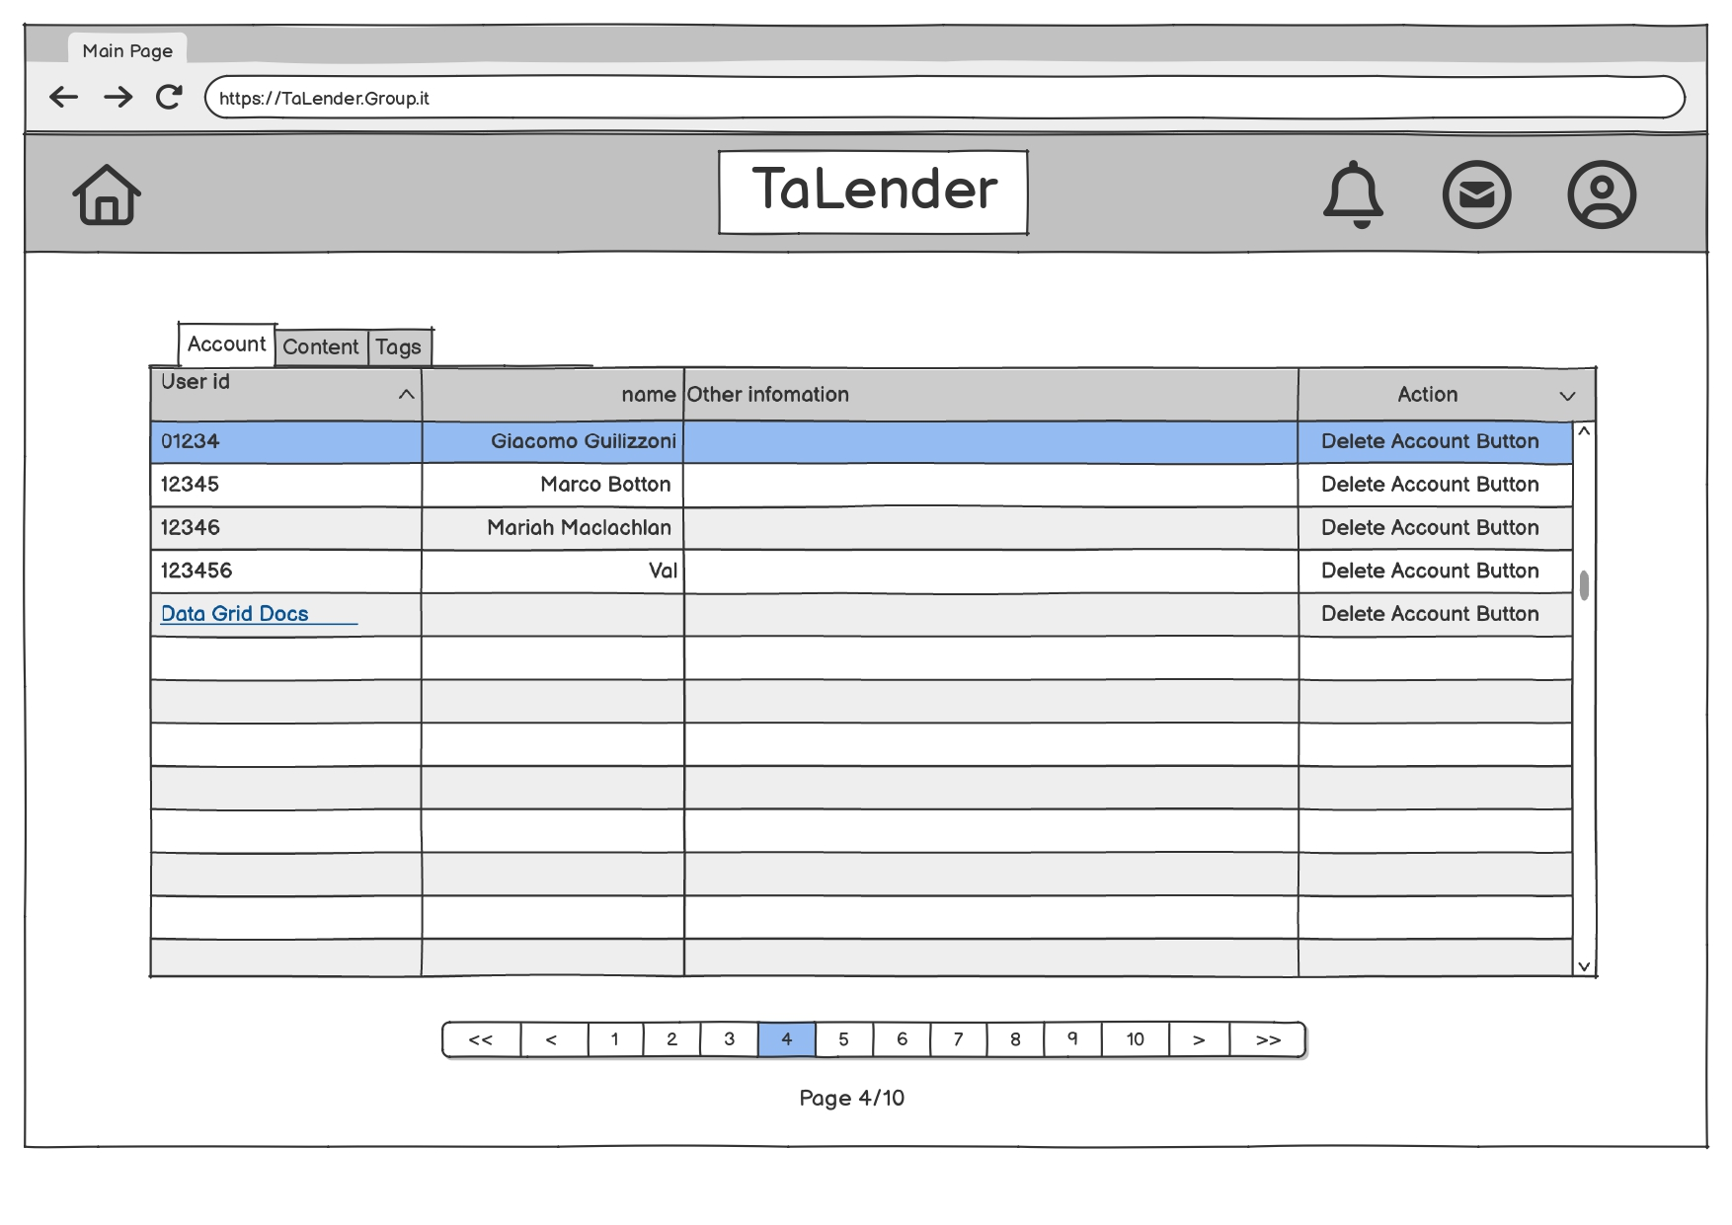

4. Function Point Analysis

4.1 Inventory & Classification
ILF | Complexity | Weight | FPs
Accounts | Average | 10 | 10
Users | Average | 10 | 10
Skills | Average | 10 | 10
Categories | Low | 7 | 7
Chats | Low | 7 | 7
Messages | Average | 10 | 10
Preferences | Low | 7 | 7
Subtotal ILF = 61
EI | Complexity | Weight | FPs
POST /register | Average | 6 | 6
POST /login | Low | 4 | 4
POST api/logout | Low | 4 | 4
POST /api/edit-user | Average | 6 | 6
POST /api/delete-user | Average | 6 | 6
POST /api/skills/add | Average | 6 | 6
POST /api/user/preference | Average | 6 | 6
POST /api/chats | Average | 6 | 6
POST /api/messages/send | Average | 6 | 6
Subtotal EI = 50
EO | Complexity | Weight | FPs
GET /api/recommendedUsers | Average | 7 | 7
GET /api/categories | Low | 5 | 5
GET /api/userId | Low | 5 | 5
Subtotal EO = 17
EQ | Complexity | Weight | FPs
GET /api/skills (filter/sort) | Average | 4 | 4
GET /api/users/search-by-username/:username | Low | 3 | 3
GET /api/user/:id/skills | Low | 3 | 3
GET /api/messages (paged) | Average | 4 | 4
GET /api/chats/user | Average | 4 | 4
Subtotal EQ = 18
No EIF. UFP (Unadjusted Function Points) = 61 + 50 + 17 + 18 = 146

5. Sizing & COCOMO II

5.1 FP → LOC
UFP | 146
LOC/FP | 30
SLOC (UFP × LOC/FP) | 4380 LOC (KLOC = 4.38)

5.2 COCOMO II
E = B + 0.01 × ΣSF → E = 0.91 + 0.01 × 18.97 = 1.0997
PM = A × KLOC^E → PM = 2.94 × 4.38^1.0997 ≈ 14.92 PM
F = D + 0.2 × (E−B) → F = 0.28 + 0.2 × (1.0997−0.91) = 0.31794
TDEV = C × PM^F → TDEV = 3.67 × 14.92^0.31794 ≈ 8.67 months

6. Project Analysis

6.1 Front-end Architecture
The following diagram illustrates the overall architecture of the frontend system.
It is organized into four main layers: Business, Data, Network, and Build. Each responsible for a specific aspect of the application, ensuring a modular, maintainable, and efficient frontend implementation.
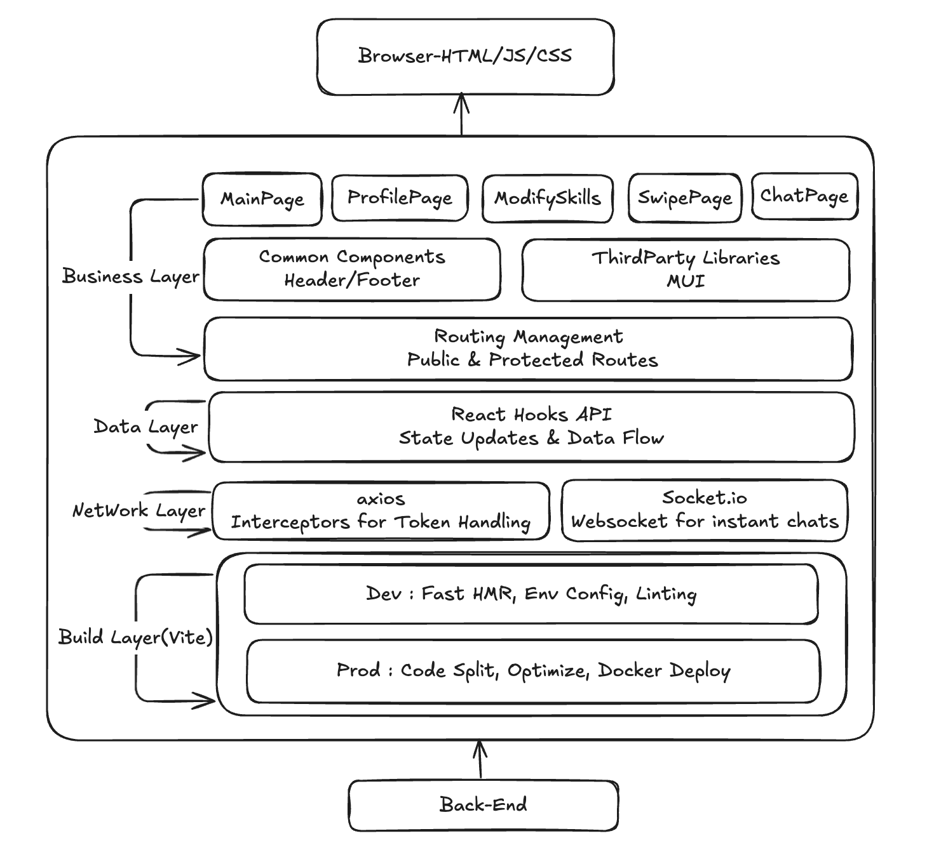

6.2 ER Schema
The following ER diagram visually represents the relationships between the key entities in the system, such as users, profiles, skills and message. This diagram serves as a blueprint for the database schema, ensuring that all user stories and functionalities are supported efficiently.
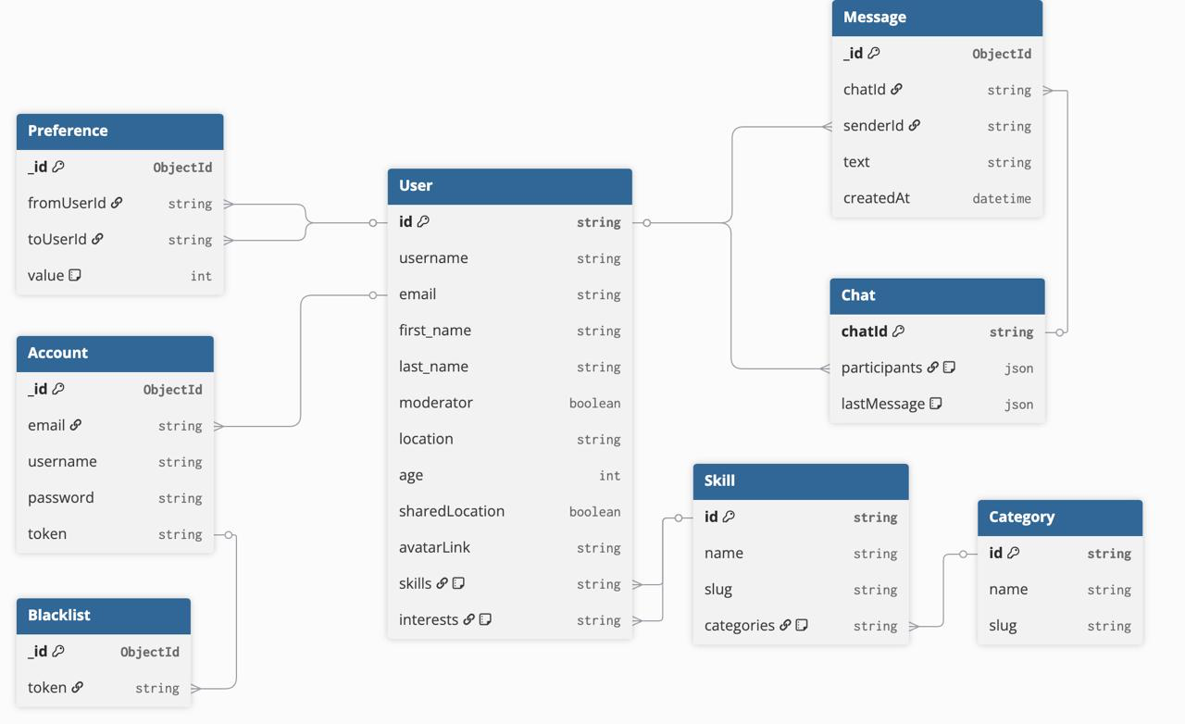

7. System architecture
The Talender Application follows a layered client-server architecture, consisting of three main components:
• Frontend (React/Typescript/MUI/Vite): Provides the website interface for all users.
•⁠ ⁠Backend (Node.js/Express/Socket/Mongoose): Handles authentication, Rest requests, Real time chatting and connection to a remote Database
•⁠ ⁠Database (MongoDB): Stores user profiles, accounts, messages, chats and all the information present on the website.
The following diagram illustrates the high-level architecture of the system:
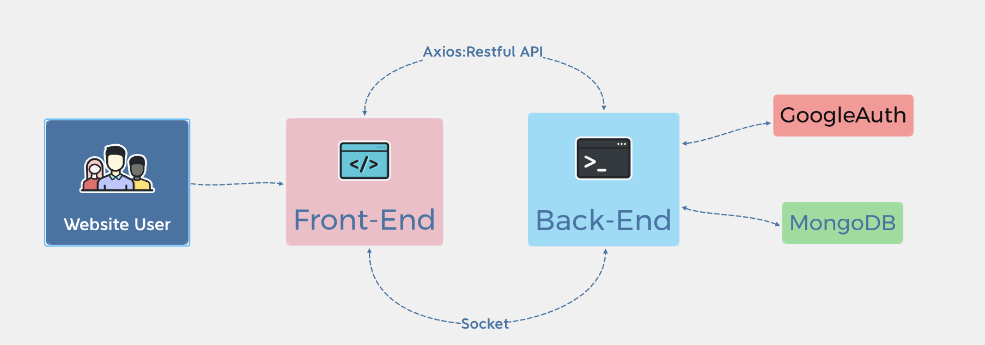
8. Conclusion
This document presented the Talender application, outlining its development through Agile Scrum methodology, Function Point and COCOMO II effort estimation, and a detailed architectural overview.
The application offers a dynamic and user-friendly platform that connects people based on their skills and interests, allowing them to discover potential matches and start a real-time chat.
The use of modern technologies and agile practices ensured iterative progress, fast feedback, and a clean, scalable codebase.

